**MAE 315 Group Project**

Chris Barnett

Dejah Singh

Darani Farari

Colbie Henson

Robert King

**Introduction:**

The purpose of this project is to compare two solving methods of the transient heat conduction equation. The Crank Nicolson Method will be used for the numerical approximation to the analytical solution.

**Project Code:**

Analytical Solution 3

Crank Nicolson Method 4

exporting to excel file 5

% MAE 315 Project 1  
% Group 5  
% 11/18/2015  
  
% given  
Ti = 40; %(F)  
Tinf = 350; %(F)  
Tf = 165; %(F)  
thetaf = (Tf-Tinf)/(Ti-Tinf); %dimensionless temperature  
h = 12.5; %Btu/hr-ft^2-F  
k = 0.287; %Btu/hr-ft-F  
alpha = 1.40e-6; %ft^2/s  
r0 = 0.331; %ft  
Bi = h*r0/k;

## Analytical Solution

% lambda values  
fb = @(x) 1-x.*cot(x)-Bi;  
lambda = zeros(6,1);  
lambda(1) = fzero(fb, 3);  
lambda(2) = fzero(fb, 6);  
lambda(3) = fzero(fb, 9);  
lambda(4) = fzero(fb, 12);  
lambda(5) = fzero(fb, 15);  
lambda(6) = fzero(fb, 18);  
  
% series solution for center temperature  
a = 4*(sin(lambda)-lambda.*cos(lambda))./(2*lambda-sin(2*lambda));  
fth1 = @(x) a(1)*exp(-lambda(1)^2*x)-thetaf;  
fth2 = @(x) fth1(x)+a(2)*exp(-lambda(2)^2*x);  
fth3 = @(x) fth2(x)+a(3)*exp(-lambda(3)^2*x);  
fth4 = @(x) fth3(x)+a(4)*exp(-lambda(4)^2*x);  
fth5 = @(x) fth4(x)+a(5)*exp(-lambda(5)^2*x);  
fth6 = @(x) fth5(x)+a(6)*exp(-lambda(6)^2*x);  
  
% Fourier Numbers  
tau = zeros(6,1);  
tau(1) = fzero(fth1, 0.1);  
tau(2) = fzero(fth2, 0.1);  
tau(3) = fzero(fth3, 0.1);  
tau(4) = fzero(fth4, 0.1);  
tau(5) = fzero(fth5, 0.1);  
tau(6) = fzero(fth6, 0.1);  
  
% time values  
time = tau*r0^2/alpha;  
  
% plot  
r = linspace(0, r0)';  
t = [time(6) time(6)-2e3 time(6)-4e3 time(6)-6e3 time(6)-8e3 time(6)-9e3];  
Tanal = zeros(length(r),6);  
figure;  
hold on;  
for j = 1:6  
 Fo = alpha*t(j)/r0^2;  
 theta = zeros(size(r));  
 for k = 1:6  
 theta = theta+a(k)*exp(-lambda(k)^2*Fo)*sin(lambda(k)*r/r0)./(lambda(k)*r/r0);  
 end  
 Tanal(:,j) = Tinf+(Ti-Tinf)*theta;  
 switch j  
 case 1  
 line = 'b';  
 case 2  
 line = 'r';  
 case 3  
 line = 'm';  
 case 4  
 line = 'g';  
 case 5  
 line = 'y';  
 case 6  
 line = 'k';  
 end  
 plot(r, Tanal(:,j), line);  
end  
plot(r, Ti*ones(length(r),1), '--k');

## Crank Nicolson Method

% given  
dr = r0/10;  
dt = 1;  
lambda = alpha*dt/dr^2;  
n = 2e5; %time levels  
r = (0:dr:r0)';  
  
% numerical calculations  
T = zeros(11,n);  
a = zeros(11,11);  
b = zeros(11,11);  
c = zeros(11,1);  
  
T(1:11,1) = Ti; %initial conditions  
rhalf = zeros(10,1); %half radii  
for j = 1:10  
 rhalf(j) = r(j)+0.5*dr;  
end  
  
c(11) = 4*h*r(11)^2*dr/k*Tinf;  
for j = 2:n  
% calculating "a" matrix  
 a(1,2) = -(rhalf(1)^2+r(1)^2);  
 a(1,1) = rhalf(1)^2+r(1)^2+2*r(1)^2/lambda;  
 for k = 2:10  
 a(k,k+1) = -rhalf(k)^2;  
 a(k,k) = rhalf(k)^2+rhalf(k-1)^2+2*r(k)^2/lambda;  
 a(k,k-1) = -rhalf(k-1)^2;  
 end  
 a(11,11) = 2*h*r(11)^2*dr/k+r(11)^2+rhalf(10)^2+2*r(11)^2/lambda;  
 a(11,10) = -(r(11)^2+rhalf(10)^2);  
% calculating "b" matrix  
 b(1,2) = rhalf(1)^2+r(1)^2;  
 b(1,1) = -(rhalf(1)^2+r(1)^2-2*r(1)^2/lambda);  
 for k = 2:10  
 b(k,k+1) = rhalf(k)^2;  
 b(k,k) = -(rhalf(k)^2+rhalf(k-1)^2-2*r(k)^2/lambda);  
 b(k,k-1) = rhalf(k-1)^2;  
 end  
 b(11,11) = -2*h*r(11)^2*dr/k-r(11)^2-rhalf(10)^2+2*r(11)^2/lambda;  
 b(11,10) = r(11)^2+rhalf(10)^2;  
% calculating T  
 T(1:11,j) = a\(b*T(1:11,j-1)+c);  
 if T(1,j) >= Tf  
 ifin = j;  
 break;  
 end  
end  
  
% plot  
plot(r, T(1:11,ifin), 'o');  
title('Temperature vs Radius');  
xlabel('r (ft)');  
ylabel('T (F)');  
legend({sprintf('Analytical (time: %.3f hours)', t(1)/3600)  
 sprintf('Analytical (time: %.3f hours)', t(2)/3600)  
 sprintf('Analytical (time: %.3f hours)', t(3)/3600)  
 sprintf('Analytical (time: %.3f hours)', t(4)/3600)  
 sprintf('Analytical (time: %.3f hours)', t(5)/3600)  
 sprintf('Analytical (time: %.3f hours)', t(6)/3600)  
 sprintf('Analytical (time: %.3f hours)', 0)  
 'Crank Nicolson'});

## exporting to excel file

r1 = (0:dr:r0)';  
r2 = linspace(0, r0)';  
filename = 'results.xlsx';  
data = [r1 interp1(r2, Tanal(:,1), r1) T(1:11,ifin)];  
xlswrite(filename, data, 1, 'A2');  
xlswrite(filename, Tanal(2,1), 1, 'B2');

**Results:**

|  |  |  |  |
| --- | --- | --- | --- |
| r (ft) | Analytical | Crank Nicolson | error |
| 0 | 165.02459 | 165.0008003 | 0.01% |
| 0.0331 | 167.40613 | 165.0008003 | 1.44% |
| 0.0662 | 174.54187 | 167.0257818 | 4.31% |
| 0.0993 | 186.16829 | 170.6575495 | 8.33% |
| 0.1324 | 201.87065 | 175.8154428 | 12.91% |
| 0.1655 | 221.04321 | 182.447899 | 17.46% |
| 0.1986 | 242.88467 | 190.5044253 | 21.57% |
| 0.2317 | 266.41479 | 199.9292081 | 24.96% |
| 0.2648 | 290.51867 | 210.6591452 | 27.49% |
| 0.2979 | 314.0189 | 222.6232904 | 29.11% |
| 0.331 | 335.76805 | 235.7429289 | 29.79% |

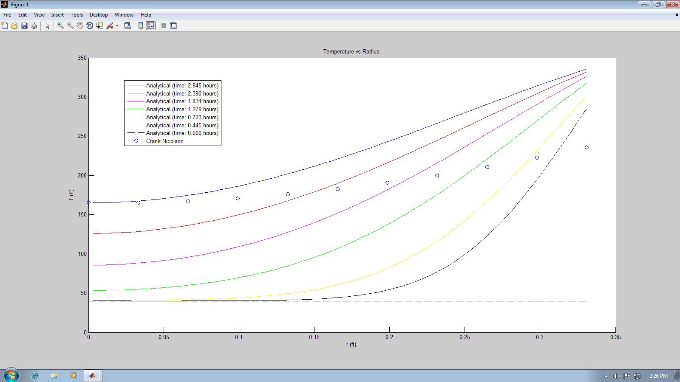

Discussion:

Conclusion: